Name : J.Lasya Madhurya Reddy
Roll No: 2503A52661
Batch:23
ASSIGNMENT-12
Task Description #1: Linear Search
Implementation with AI Assistance
Task: Use an AI tool to generate a Python program that implements the Linear Search
algorithm.
Instructions:
Prompt AI to create a function linear_search(arr, target) that searches
for a target element in a list.
Return the index of the target element if found; otherwise, return -1.
Ask AI to include a docstring explaining the best-case, average-case, and
worst-case time complexities.
Test the function with different inputs, including an empty list and a target that
is not present.
Expected Output:
A working Python program implementing Linear Search.
Test cases with outputs.
A brief explanation of time complexity.
PROMPT:
Write a simple Python program for Linear Search using linear_search(arr, target). Return the index if found, otherwise return -1. Include a docstring explaining best, average, and worst-case time complexity. Test with normal inputs, an empty list, and a target not present. Show outputs and briefly explain the algorithm.

Include all required test casesMention the one-element test
CODE:
def linear_search(arr, target):
"""Return target's index, or -1 if absent.

Time complexity: best case O(1), average case O(n), worst case O(n).
"""
for index, value in enumerate(arr):
if value == target:
return index
return -1

# Linear search checks items in order until the target is found or the list ends.
tests = [
("normal input", [4, 2, 7, 1], 7),
("empty list", [], 3),
("target not present", [5, 8, 9], 2),
("one-element test", [6], 6),
]

for description, arr, target in tests:
print(f"{description}: {linear_search(arr, target)}")

OUTPUT:
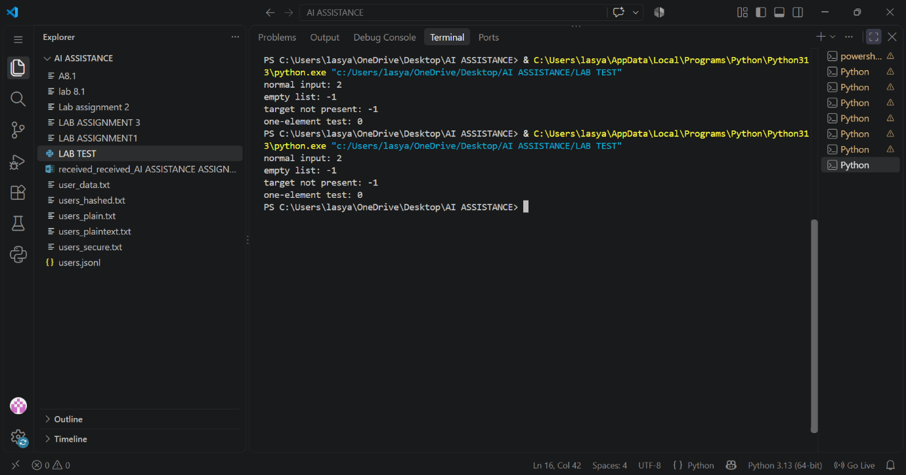
Task Description #2: Binary Search
Implementation with AI Optimization
Task: Use AI to generate an efficient Python program that implements Binary Search
on a sorted list.
Instructions:
Prompt AI to create a function binary_search(arr, target).
Use the iterative approach to find the target element.

Return the index if the element is found; otherwise, return -1.
Ask AI to explain why the input list must be sorted.
Include best-case, average-case, and worst-case time complexities.
Test the program with the first element, last element, middle element, and a
missing element.
Expected Output:
A working Binary Search program.
Test results for different target values.
An explanation of why Binary Search is more efficient than Linear Search for
large, sorted lists.
PROMPT:
Write a simple Python program implementing iterative Binary Search using binary_search(arr, target) on a sorted list. Return the index if found, otherwise -1. Explain why the list must be sorted and include best, average, and worst-case time complexities. Test the first, last, middle, and a missing element. Briefly compare Binary Search with Linear Search.
CODE:
def binary_search(arr, target):
"""Return target's index in a sorted list, or -1 if it is absent."""
low, high = 0, len(arr) - 1

while low <= high:
middle = (low + high) // 2
if arr[middle] == target:
return middle
elif arr[middle] < target:
low = middle + 1
else:
high = middle - 1

return -1

if __name__ == "__main__":
numbers = [2, 4, 6, 8, 10, 12, 14]
tests = [("first", 2), ("last", 14), ("middle", 8), ("missing", 7)]
for label, target in tests:
print(f"{label} ({target}): index {binary_search(numbers, target)}")

# The list must be sorted so each comparison can discard the half that
# cannot contain the target. Best case: O(1); average/worst: O(log n).
# Linear search works on unsorted lists, but is O(n) on average and worst;
# binary search is faster when the data is sorted.

OUTPUT:
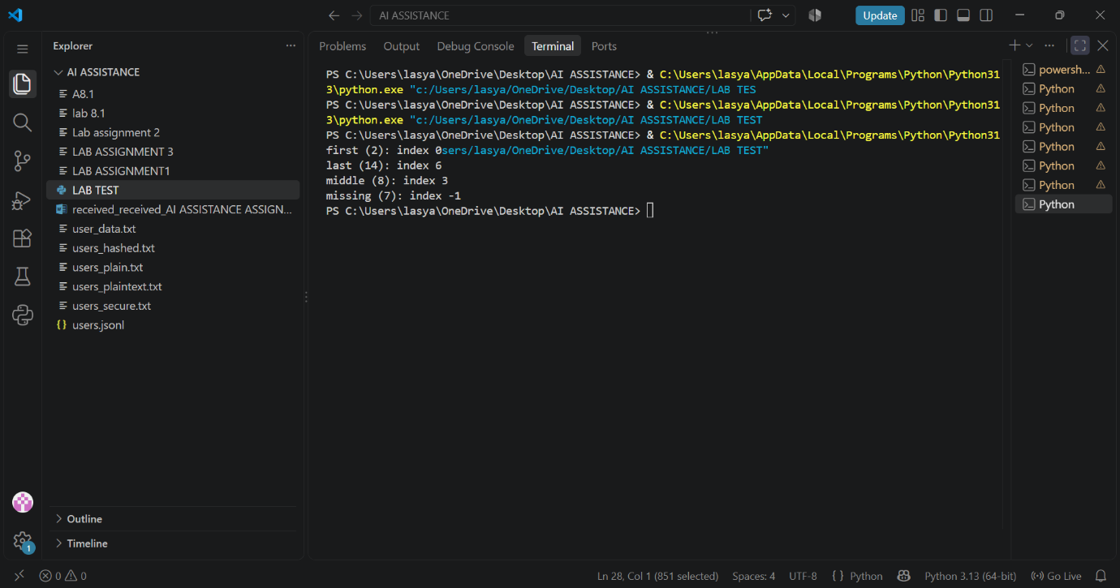
Task Description #3: Student Record Search
System
Scenario: A university maintains student records containing roll numbers, names, and
marks. Faculty members need to search for student records using roll numbers.
Student Task:
Use AI to recommend either Linear Search or Binary Search for searching
student roll numbers.
Implement both algorithms in Python.
Test the algorithms using a list of student roll numbers.
Compare the results when the roll numbers are stored in unsorted and sorted
order.
Explain the time complexity of both algorithms.
Expected Output:
Python functions for Linear Search and Binary Search.
Sample student records and test results.
A comparison table showing algorithm, input requirements, and time
complexity.
Justification for selecting the appropriate search algorithm.
PROMPT:
Write a simple Python program for a Student Record Search System using both Linear Search and Binary Search. Search student roll numbers and display the student record. Test with unsorted and sorted roll numbers. Include sample records, test results, a comparison table of input requirements and time complexities, and explain which algorithm is better and why.
CODE:
"""Student Record Search System: Linear Search vs. Binary Search."""

def linear_search(records, roll_number):
"""Find a student in records in any order."""
for record in records:
if record["roll_number"] == roll_number:
return record
return None

def binary_search(records, roll_number):
"""Find a student in records sorted by roll number."""
low, high = 0, len(records) - 1
while low <= high:
middle = (low + high) // 2
current = records[middle]["roll_number"]
if current == roll_number:
return records[middle]
if current < roll_number:
low = middle + 1
else:
high = middle - 1
return None

def display_result(method, roll_number, record):
if record is None:
print(f"{method}: roll number {roll_number} -> No student found")
else:
print(
f"{method}: roll number {roll_number} -> "
f"Name: {record['name']}, Class: {record['class']}"
)

def main():
# Unsorted sample records for linear search.
unsorted_records = [
{"roll_number": 104, "name": "Asha", "class": "10A"},
{"roll_number": 101, "name": "Ben", "class": "10B"},
{"roll_number": 103, "name": "Chitra", "class": "10A"},
{"roll_number": 102, "name": "Dev", "class": "10C"},
]
# Binary search requires records sorted by roll number.
sorted_records = sorted(unsorted_records, key=lambda r: r["roll_number"])

print("Student Record Search System")
print("Unsorted roll numbers:", [r["roll_number"] for r in unsorted_records])
print("Sorted roll numbers: ", [r["roll_number"] for r in sorted_records])

print("\nTest results:")
for roll_number in (103, 105):
display_result(
"Linear search (unsorted)", roll_number,
linear_search(unsorted_records, roll_number),
)
display_result(
"Binary search (sorted)", roll_number,
binary_search(sorted_records, roll_number),
)

print("\nComparison table:")
print("Algorithm | Input requirement | Best | Average | Worst")
print("Linear search | Any order | O(1) | O(n) | O(n)")
print("Binary search | Sorted by roll no.| O(1) | O(log n)| O(log n)")
print(
"\nWhich is better? Binary search needs sorted data, but is faster for "
"repeated searches in large sorted records (O(log n) per search). "
"Linear search works directly on unsorted data and is a good choice "
"for small lists; sorting solely for one search may not be worthwhile."
)

if __name__ == "__main__":
main()

OUTPUT:
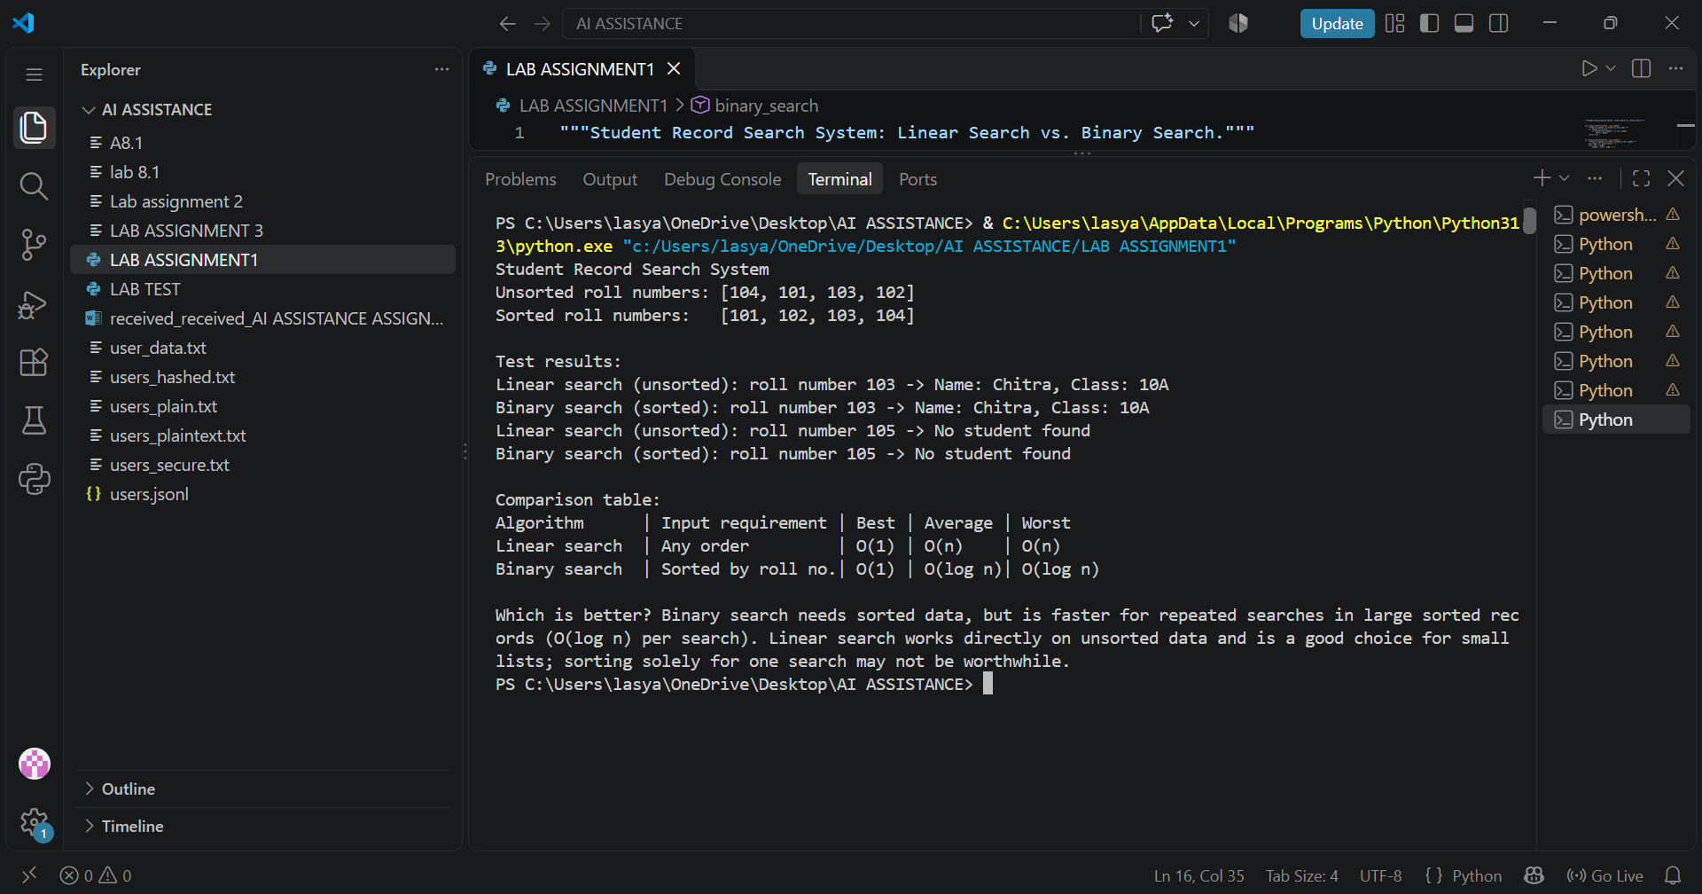
Task Description #4: Library Book Search
System
Scenario: A college library maintains a list of book identification numbers. Students
and librarians need to find books quickly using their book IDs.
Student Task:
Use AI to generate a Python program that searches for a book ID using Linear
Search.
Implement Binary Search to search for the same book ID in a sorted list.
Test both algorithms when the book ID exists and when it does not exist.
Measure and compare the number of comparisons performed by each
algorithm.
Ask AI to explain which algorithm is suitable for a large, sorted collection of
book IDs.
Expected Output:
Working Python programs for both searching algorithms.
Test cases with search results.
A comparison of the number of comparisons performed.
A conclusion explaining the efficiency of each algorithm.
PROMPT:
Write a simple Python program for a Library Book Search System using Linear Search and Binary Search. Search for a book ID and return its index or -1 if not found. Count and compare the number of comparisons for both algorithms. Test with existing and missing book IDs. Explain which algorithm is more efficient for a large, sorted collection and why.
CODE:
def linear_search(book_ids, target):
"""Return the target's index and number of comparisons."""
comparisons = 0
for index, book_id in enumerate(book_ids):
comparisons += 1
if book_id == target:
return index, comparisons
return -1, comparisons

def binary_search(book_ids, target):
"""Search a sorted list; return the target's index and comparisons."""
low, high = 0, len(book_ids) - 1
comparisons = 0

while low <= high:
middle = (low + high) // 2
comparisons += 1
if book_ids[middle] == target:
return middle, comparisons
if book_ids[middle] < target:
low = middle + 1
else:
high = middle - 1

return -1, comparisons

def main():
# Binary search requires the book IDs to be sorted.
book_ids = [104, 118, 203, 256, 310, 417, 502, 689]
test_ids = [256, 999] # One existing ID and one missing ID.

print("Book IDs:", book_ids)
for target in test_ids:
linear_index, linear_comparisons = linear_search(book_ids, target)
binary_index, binary_comparisons = binary_search(book_ids, target)
print(f"\nSearching for book ID {target}:")
print(f" Linear search: index {linear_index}, {linear_comparisons} comparisons")
print(f" Binary search: index {binary_index}, {binary_comparisons} comparisons")

print(
"\nFor a large sorted collection, binary search is more efficient: "
"it halves the remaining search range each step (O(log n)), while "
"linear search may inspect every book (O(n))."
)

if __name__ == "__main__":
main()
OUTPUT:
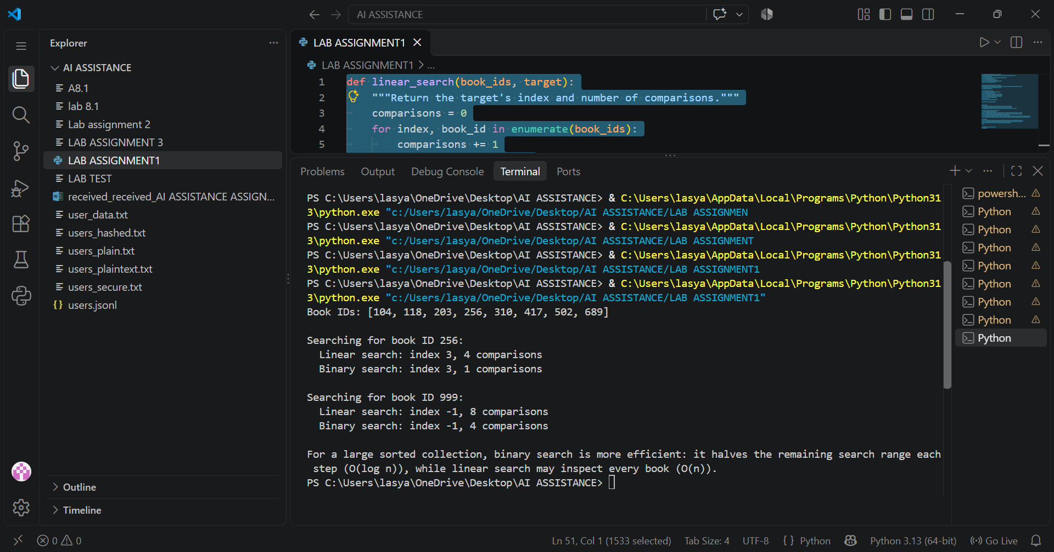
Task Description #5: Searching Algorithm
Comparison and Optimization
Scenario: An online shopping platform maintains product IDs for thousands of
products. The system must locate a product quickly when a customer enters a product
ID.
Student Task:
Use AI to generate Python implementations of Linear Search and Binary
Search.
Test both algorithms using the same collection of product IDs.
Compare the execution time and number of comparisons for different input
sizes.

Test the algorithms with the first element, middle element, last element, and an
element that does not exist.
Ask AI to suggest optimizations and explain the limitations of each algorithm.
Present the results in a table and justify which algorithm is appropriate for
sorted product IDs.
Expected Output:
Python implementations of both algorithms.
Test results for different input sizes.
A comparison table containing execution time, number of comparisons, and
time complexity.
A brief conclusion based on the experimental results.
PROMPT:
Write a simple Python program implementing Linear Search and Binary Search for product IDs. Test both using the same sorted product ID lists of different sizes. Search for the first, middle, last, and missing elements. Measure execution time and number of comparisons. Present results in a table, explain time complexities, suggest optimizations and limitations, and conclude which algorithm is best for sorted product IDs.
CODE:
"""Compare linear and binary search for sorted product IDs."""

from time import perf_counter_ns

def linear_search(product_ids, target):
comparisons = 0
for index, product_id in enumerate(product_ids):
comparisons += 1
if product_id == target:
return index, comparisons
return -1, comparisons

def binary_search(product_ids, target):
low, high = 0, len(product_ids) - 1
comparisons = 0
while low <= high:
middle = (low + high) // 2
comparisons += 1
if product_ids[middle] == target:
return middle, comparisons
comparisons += 1
if target < product_ids[middle]:
high = middle - 1
else:
low = middle + 1
return -1, comparisons

def timed_search(search, product_ids, target, repetitions=1000):
start = perf_counter_ns()
for _ in range(repetitions):
index, comparisons = search(product_ids, target)
average_ns = (perf_counter_ns() - start) / repetitions
return index, comparisons, average_ns

def main():
print(f"{'Size':>5} {'Case':>8} {'Algorithm':>9} {'Result':>10} {'Comparisons':>11} {'Avg time (ns)':>14}")
print("-" * 64)
for size in (10, 100, 1000):
# The same sorted list is used for both algorithms in each test.
product_ids = list(range(1001, 1001 + size))
targets = (
("first", product_ids[0]),
("middle", product_ids[size // 2]),
("last", product_ids[-1]),
("missing", product_ids[-1] + 1),
)
for case, target in targets:
for name, search in (("Linear", linear_search), ("Binary", binary_search)):
index, comparisons, average_ns = timed_search(search, product_ids, target)
result = str(index) if index != -1 else "not found"
print(f"{size:5} {case:>8} {name:>9} {result:>10} {comparisons:11} {average_ns:14.1f}")

print("""
Time and space complexity:
- Linear search: O(n) worst-case time, O(1) extra space.
- Binary search: O(log n) worst-case time, O(1) extra space; requires sorted,
indexable data.

Optimizations and limitations: Keep IDs sorted if binary searches are frequent;
inserting into a sorted array can be O(n). A hash table can offer average O(1)
lookups when ordering is unnecessary. Linear search is simple and can be faster
for tiny lists or a one-off lookup when sorting would be required. Timings vary
by machine, so comparison counts provide a deterministic comparison.

Conclusion: For large product ID lists that are already sorted and searched
repeatedly, binary search is generally the better choice.
""")

if __name__ == "__main__":
main()

OUTPUT:

